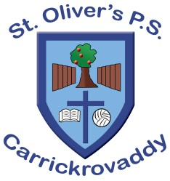St Oliver’s Primary School, Carrickrovaddy

2 Roxborough Road

Cullyhanna, Newry,

BT35 0QJ

Tel: 028 30 878225

Website: www.stoliverspscarrickrovaddy.co.uk

Hi Everyone,

I hope you are all enjoying your well earned summer break.

As you know, Mr Colin Woods will be retiring as Principal from St Oliver's Primary School on 31 August, 2023.

On behalf of the Board of Governors I would like to thank Colin for his leadership, commitment and service to St Olivers over the past few years.

I would also like to take this opportunity to wish Colin a happy retirement and the very best in his future endeavours.

Following discussions with CCMS, I am pleased to let you know that Mr Caolán Byrne will take on the role as Acting Principal of St Oliver's Primary School.

Mr Byrne is the current Vice Principal of St Ronan's Primary School, Newry, and is also his school's SENCo and Designated Teacher for Child Protection.

The appointment of Mr Byrne in the short term will ensure the least disruption to the school management and the education of the children.

I know you will give a warm welcome to Mr Byrne as he joins our school community at the end of August.

In relation to arrangements for a full-time appointment of Principal, the Board of Governors are working with CCMS to publicly advertise the post and finish the recruitment process prior to Halloween. We would then hope that the successful candidate can take up post after Christmas.

Regards,

Mr P Carragher

(Chair of the Board of Governors)