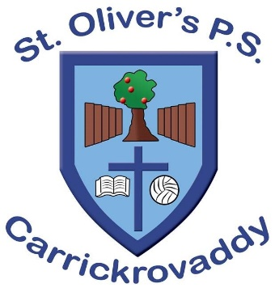

1st September 2020

Dear Parent/Carer
I hope you are all keeping well.
Please complete the data information sheets and return to the school so we have the most up to date contact information for our pupils in case of emergency. One form is to be completed for each child.
The data forms can be accessed via our school website in Parents/School letters and can be returned via email to our school secretary fmccreesh943@stolivers.carrickrovaddy.ni.sch.uk.
If parents do not have access to our school website/App please contact our school secretary by email for further information.
Data information sheets to be returned by Monday 7th September 2020.

Yours Sincerely
Colin Woods
Principal

St Oliver’s Primary School
Roxborough Rd
Cullyhanna Newry
Down
BT35 0QJ
Tel: 028 30878225

